Using Multifactor Authentication (MFA) with VPN:
New portal address for VPN is AZURE-PORTAL.okcu.edu. Please add the portal to the Global Protect Client. Note: By Wednesday, 2-24-2021 you will need to have MFA set up. Beginning Thursday, 2-25-2021 you will be prompted for a code (MFA) when accessing VPN or any Office 365 applications, such Outlook. The OCU-PORTAL.okcu.edu will no longer be available after 5:00 PM on 2-26-2021.
Adding the new portal:
- Click on the 3 lines in the upper right corner and choose Settings.
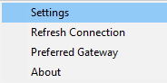
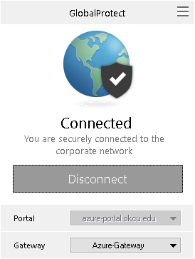
- Click on Add on the General Tab and enter “azure-portal.okcu.edu” for the address.
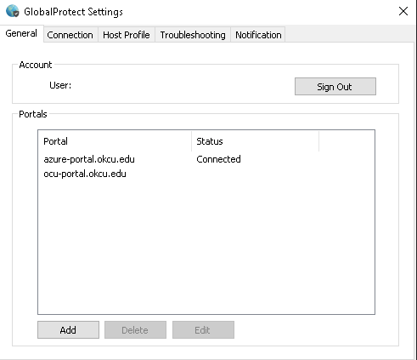
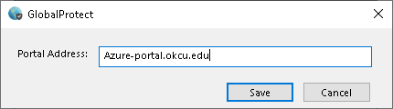
To connect:
- Change portal on the Global Protect Client to azure-portal.okcu.edu and click connect.
- Once the multi-factor authentication has been enabled on your account, you will get a pop-up to sign in. Use your full email address for the username.
- Enter the code sent via text. Check Don’t ask again for 30 days if you do not want to be prompted each day and click Verify.

