To set up Multifactor Authentication (MFA) for the first time:
- Go to www.outlook.com and click Sign in.
- Enter your full email address for the username and click Next.
- Choose Work or School Account and click Next (if prompted).
- Complete 2 of 3 authentication options. Note: Cell phone is required to be one of your selected options.
- If you have previously logged into the web interface, you will need to verify your credentials and select authentications options using the steps below: To set up Multifactor Authentication (MFA) for the first time within Outlook Web Interface.

To set up Multifactor Authentication (MFA) for the first time within Outlook Web Interface:
- Click your picture (may be initials) in the upper right corner (to the right of the “?”) and choose View Account.
- Click Update Info.
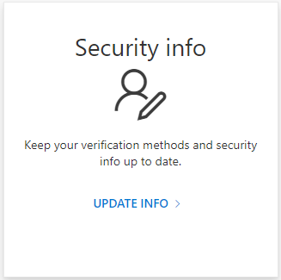

- From this page enter any new or update your authentication information, or click Enable two-step verification for any of the methods.
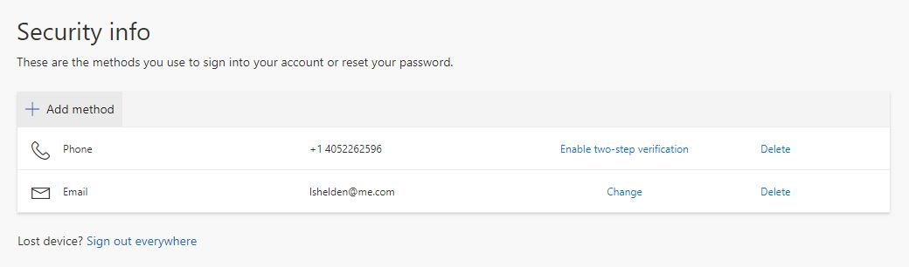
Note: If you use a phone or tablet to access your email, you will also need to add the method Authenticator App. For instructions on Microsoft Authenticator, visit the following:
- Setup Authenticator for iPhone/iPad: https://www.youtube.com/watch?v=3bTm05_Hqec
- Setup Authenticator for Android device: https://www.youtube.com/watch?v=LxTwiqnGbNg

